MODULE 0: BASICS
Contents
- JAVA 1
- How Java code executes? 2
- OOPS 4
- OOPS vs POPS 5
- Basics of OOPS 6
- Objects vs Classes 7
- Java Packages 9
- Keywords in java 9
- Data Types 10
- Type Casting 11
- Access Specifier 11
- Methods 12

JAVA
Java is a widely-used, high-level, object-oriented programming language known for its portability, robustness, and security features. Here are its key properties:
- Object-Oriented: Java is designed around the concept of objects. It uses classes and objects to organize code and data. Key object-oriented principles in Java include encapsulation, inheritance, polymorphism, and abstraction. These concepts allow java programs to be more modular, reusable, and maintainable.

- Platform Independence: Java programs are compiled into bytecode, which can be executed on any device equipped with the Java Virtual Machine (JVM). This "write once, run anywhere" capability makes Java platform-independent.

- Simple: Java is designed to be easy to learn and use. It has a clean and straightforward syntax that eliminates many of the complexities of other languages, like C++ (e.g., no pointers, no operator overloading).

- Secure: Java includes robust security features, such as bytecode verification, sandboxing, and the Java security manager, which help protect against malicious code and vulnerabilities.

- Robust: Java emphasizes reliability and robustness. It has strong memory management, exception handling, and type-checking mechanisms, which help prevent runtime errors and make the language more stable.

- Multithreaded: Java supports multithreading, allowing multiple threads of execution within a single program. This enables efficient use of resources and better performance in applications that require parallel processing.

- Architecture-Neutral: Java's bytecode is architecture-neutral, meaning that it does not depend on the underlying hardware or operating system. This ensures that Java applications can run on any platform that supports the JVM.

- Interpreted: Java is both compiled and interpreted. The Java compiler converts source code into bytecode, which is then interpreted by the JVM. This process allows Java programs to be executed on any device with a compatible JVM.

- High Performance: Although Java is an interpreted language, it offers high performance through Just-In-Time (JIT) compilation, where the JVM compiles bytecode to native machine code at runtime, improving execution speed.

- Distributed: Java is designed for the distributed environment of the internet. It includes extensive libraries for networking, making it easier to develop distributed applications.

- Dynamic: Java is a dynamic language that can adapt to an evolving environment. It supports dynamic loading of classes and interfaces, making it easier to integrate with other systems and applications.

- Automatic Memory Management (Garbage Collection): Java automatically manages memory through garbage collection. The JVM automatically identifies and removes objects that are no longer needed, reducing the risk of memory leaks and improving overall application performance.

How Java code executes?

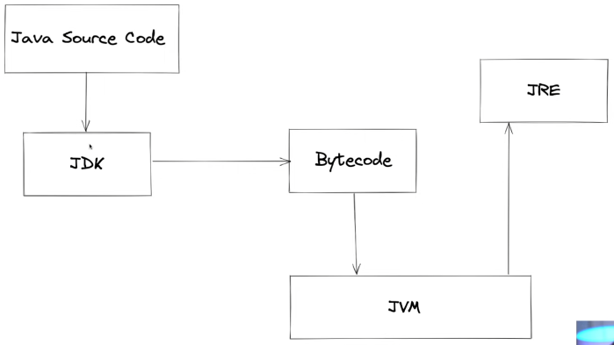

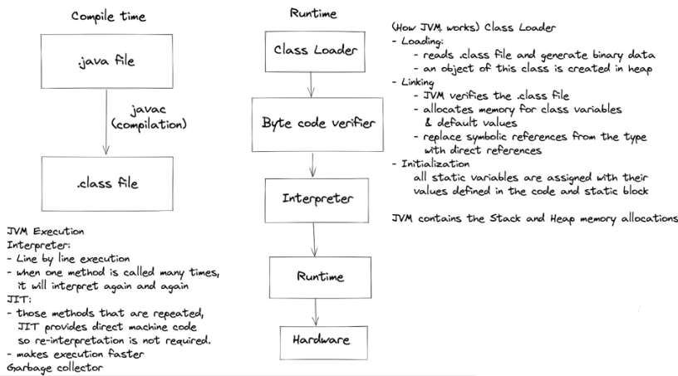
- JVM (Java Virtual Machine): The JVM is a virtual machine that provides a runtime environment to execute Java bytecode. It is platform-independent, meaning the same Java program can run on any device that has a JVM, regardless of the underlying hardware and operating system. Responsibilities:
    - Execution of Bytecode: The JVM reads and executes compiled Java bytecode.
    - Memory Management: It handles memory allocation and garbage collection.
    - Security: The JVM includes features to ensure that Java programs are secure, such as bytecode verification and sandboxing.
    - Thread Management: The JVM manages multiple threads, allowing for concurrent execution within Java programs.
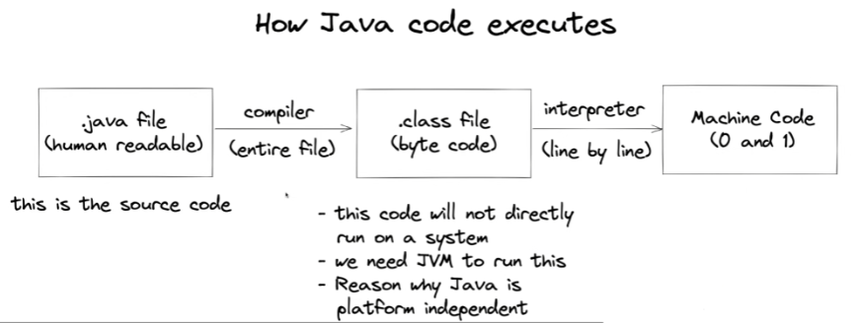

- Byte Code: Java bytecode is an intermediate language that is generated by compiling a Java program. It is a machine code that runs on the Java virtual machine. It is made up of a series of instructions that tell the JVM how to execute the program. The JVM interprets the bytecode and executes the corresponding instruction.
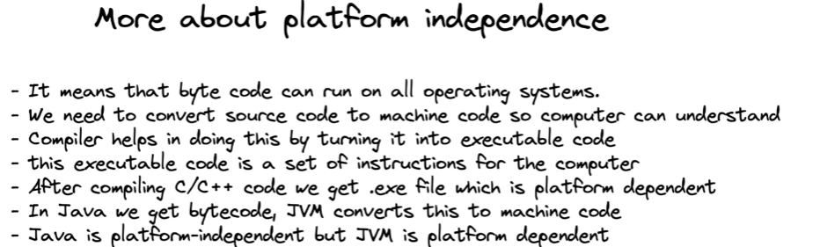

- JRE (Java Runtime Environment): The JRE is a part of the Java Development Kit (JDK) that provides the necessary libraries and resources for running Java applications. It includes the JVM, core libraries, and other components to support the execution of Java programs. Components:
    - JVM: The core component that executes the bytecode.
      - Class Libraries: A set of pre-written classes that provide commonly used functionality, such as data structures, networking, and file I/O.
      - Supporting Files: Configuration files, properties, and other resources that Java applications might require at runtime.
    - Use: The JRE is what you need to run Java applications. Developers typically need the JDK, which includes the JRE, to develop Java applications.
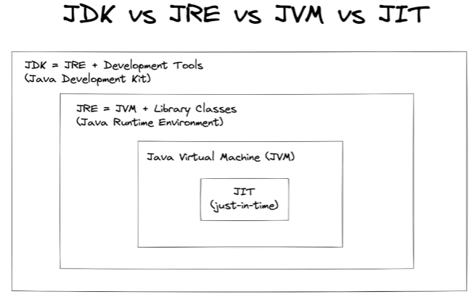
- JVM TI (Java Virtual Machine Tool Interface): JVM TI is a programming interface that provides tools and agents with the ability to inspect and control the state and execution of applications running in the JVM. It is primarily used for debugging, profiling, and monitoring Java applications. Key Features:
    - Debugging: JVM TI allows for the inspection of running programs, setting breakpoints, stepping through code, and examining variables.
    - Profiling: Tools can use JVM TI to monitor and analyze the performance of Java applications, including CPU usage, memory allocation, and thread activity.
    - Event Notification: JVM TI can notify tools of various events within the JVM, such as class loading, garbage collection, and exceptions.
    - Usage: JVM TI is often used by developers to build debugging and profiling tools, such as IDEs (Integrated Development Environments) and performance analyzers.

OOPS
OOPS is a programming paradigm that models real-world entities as objects that have attributes (data) and behaviours (methods) rather than functions and logic.
OOPS focuses on the objects that developers want to manipulate rather than the logic required to manipulate them. Additional benefits of OOPS include code reusability, scalability, and efficiency.
The main objective of OOPS is to bind the data and the functions that operate on them together, so that no other part of the code can access the data except that function.

OOPS vs POPS
Feature | OOP | POP
Definition | OOPS is a programming paradigm that models real-world entities as objects that have attributes (data) and behaviors (methods) | POPS is a programming paradigm that focuses on procedures or routines (also known as functions) to perform tasks. The program is divided into a set of functions, each performing a specific operation. In POPS, the emphasis is on the sequence of steps (procedures) needed to solve a problem.
Data Encapsulation | Encapsulates data and methods within objects. This encapsulation ensures that data is only accessed through methods, which provides better control and security. | Data and functions are separate. Functions can access and modify data directly, which can lead to less control over data and potential issues with data integrity.
Inheritance, Polymorphism, Abstraction | - Supports inheritance, allowing classes to inherit properties and methods from parent classes.  - Supports polymorphism, allowing objects of different classes to be treated as if they were objects of the same class.  - Provides a high level of abstraction. Objects represent real-world entities, making the code more intuitive and easier to understand. | - No inheritance  - No polymorphism  - Provides a lower level of abstraction. The focus is on the process rather than the data, which can make the code harder to understand, especially in complex systems.
Modularity | Promotes high modularity. Each object is a self-contained unit that can be developed and tested independently. This makes code easier to maintain, modify, and extend. | Modularity is achieved by dividing the program into functions, but it’s often less modular than OOPS because functions are interdependent and share global data.
Code Reusability | High code reusability through inheritance and polymorphism | Lower code reusability compared to OOP. Functions can be reused, but it’s often harder to reuse code across different programs because of the lack of encapsulation and dependence on global data.
Maintainability | Easier to maintain and modify due to modularity and encapsulation | Can be harder to maintain as code grows in complexity
Security | Enhances security by encapsulating data within objects and controlling access through access modifiers (private, public, protected). | Offers less security since data is usually accessible by all functions within the program, leading to potential data corruption.
Example of Use Cases | Used in large, complex applications where modularity, reusability, and real-world modeling are important, such as in enterprise software, game development, and simulation software. | Suitable for smaller, simpler programs where performance and simplicity are key, such as in embedded systems or legacy software.
Example Languages | Java, C++, Python, Ruby, C# | C, Pascal, FORTRAN

Basics of OOPS
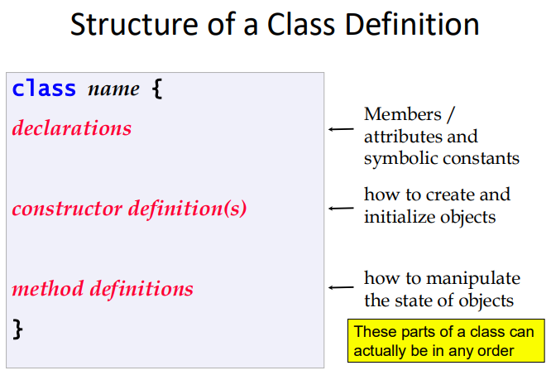
- Classes: A class is a blueprint or template for creating objects. It defines a set of attributes (data) and methods (functions) that the objects created from the class will have. A class encapsulates data for the object and methods to manipulate that data.

- Object: An object is an instance of a class. It is a concrete entity that has a state (attributes) and behaviour (methods). Objects represent real-world entities and interact with one another in an object-oriented program.

- Data Abstraction: Data abstraction refers to the concept of hiding the complex implementation details and showing only the essential features of an object. It allows users to interact with the object at a higher level without needing to understand the inner workings.

- Encapsulation: Encapsulation is the process of bundling data (attributes) and methods (functions) that operate on the data into a single unit, typically a class. It restricts direct access to some of an object's components, which can protect the object’s integrity by preventing outside interference and misuse.

- Inheritance: Inheritance is a mechanism by which one class (known as the subclass or derived class) can inherit properties and behaviours (methods) from another class (known as the superclass or base class). This allows for code reuse and the creation of hierarchical relationships between classes.

- Polymorphism: Polymorphism is the ability of different classes to be treated as instances of the same class through a common interface. It allows one interface to be used for a general class of actions, with specific behaviour being determined by the exact nature of the class or object.

- Dynamic Binding: Dynamic binding, also known as late binding, refers to the process where the method to be executed in response to a method call is determined at runtime rather than at compile-time. It enables polymorphism by allowing objects to decide which method to invoke based on the actual object type at runtime.

- Message Passing: Message passing is the process by which objects communicate with one another. An object sends a message (typically a method call) to another object, requesting it to perform an action or provide some data. This communication is key to interaction in object-oriented programming, allowing objects to work together to accomplish tasks.

Objects vs Classes
Feature | Object | Class
Definition | An object is an instance of a class. It is a concrete entity that has a state (attributes) and behaviour (methods). Objects represent real-world entities and interact with one another in an object-oriented program. | A class is a blueprint or template for creating objects. It defines a set of attributes (data) and methods (functions) that the objects created from the class will have. A class encapsulates data for the object and methods to manipulate that data.
Relationship | Objects are created from classes | Classes define the structure and behaviour of objects
Data | Contains specific values for attributes defined in the class | Defines the attributes that objects will have
Behaviour | Exhibits the methods (functions) defined in the class | Defines the methods that objects will have
Memory allocation | Objects allocate memory space whenever they are created | When a class is created no memory is allocated
As an entity | Object is a physical entity. | Class is a logical entity
Units | Many objects can be created using a class. | We declare class only once
Example | A specific car (e.g., a red Toyota Corolla) | The blueprint for a car, defining its properties and methods

  - Instance Variable: An instance variable is a variable that is defined in a class and each object (or instance) of that class has its own copy of the variable. These variables hold the state of an object, meaning they store the data specific to that instance. Instance variables are typically declared within a class but outside any method, constructor, or block. Example: If you have a class Car, an instance variable might be color or modelYear, with each Car object having its own specific color or model year.

  - Attribute of a Class: An attribute of a class refers to a characteristic or property that describes the objects created from that class. Attributes are essentially the data fields or instance variables in a class. They define what an object knows about itself. Example: In a Person class, attributes might include name, age, and address, which store the relevant information for each Person object.

  - Class Abstraction: Class abstraction is the concept of defining a class in such a way that it exposes only the essential features needed for interaction while hiding the complex internal details. This allows the class to be used without needing to understand its internal workings fully. Example: A BankAccount class might allow users to deposit and withdraw money, but the internal process of updating balances and ensuring security is abstracted away from the user.

  - Class as an Object Factory: The concept of a class as an object factory refers to the idea that a class acts as a blueprint or template from which objects are created. The class defines the structure and behaviour, and when an object is instantiated from the class, it is produced or "manufactured" according to that blueprint. Example: A Robot class might be designed to produce multiple Robot objects, each with the same basic capabilities but different configurations or behaviours based on the class definition.

  - Class as a User-Defined Data Type: A class is considered a user-defined data type because it allows the programmer to create new types that represent complex entities in a program. These data types go beyond the built-in data types like integers or strings, allowing for the modeling of real-world entities. Example: When you create a Student class, you are defining a new data type that represents students, with attributes such as name, rollNumber, and methods to manipulate this data.

  - Class as a Composite Data Type: A class is a composite data type because it can contain multiple variables (attributes) of different types and methods to operate on those variables. This means that a class can represent complex data structures by combining several pieces of information into one entity. Example: A LibraryBook class could include attributes like title, author, ISBN, and checkedOut status, representing the complex nature of a book in a library system.

  - Object as an Instance of a Class: An object is an instance of a class, meaning it is a specific realization of the class blueprint. When a class is defined, no memory is allocated until objects of that class are created. Each object is a unique instance with its own set of instance variables (attributes). Example: If you have a class Dog, creating an object from this class might look like Dog myDog = new Dog();. myDog is now an instance of the Dog class, with its own attributes like name, breed, and age.

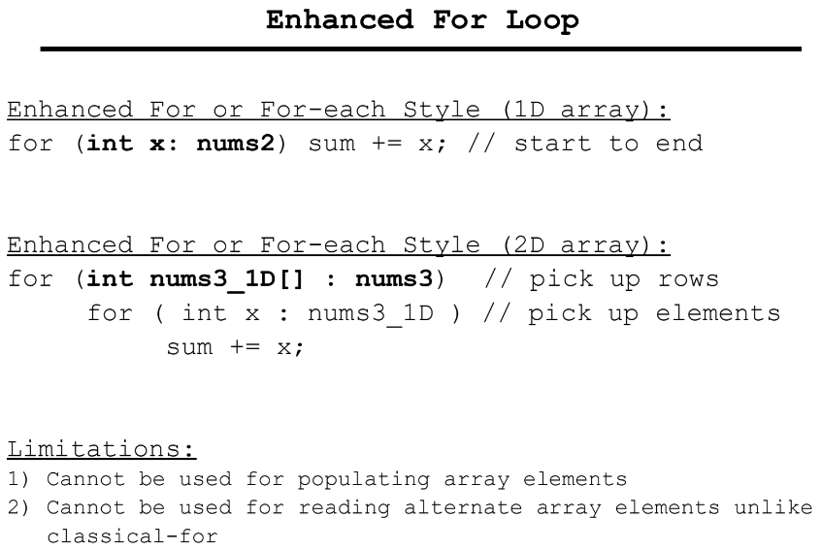

Java Packages
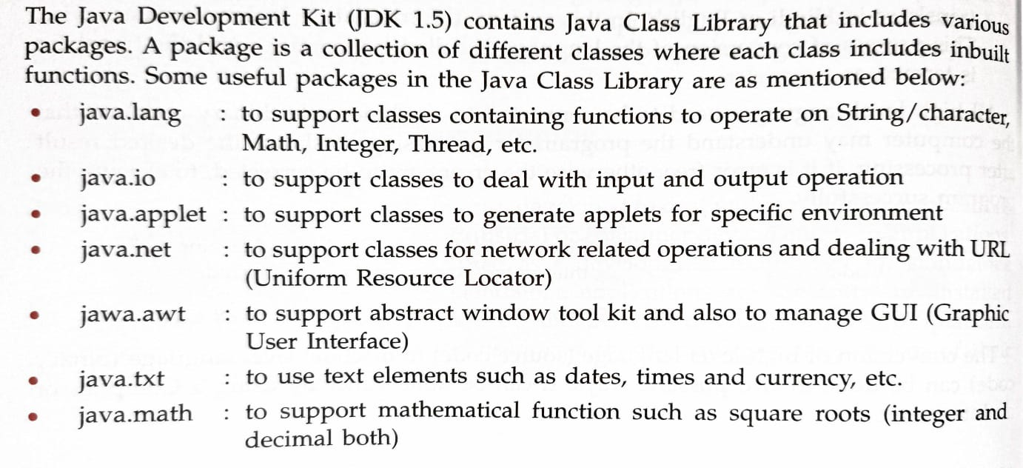
Importance of packages
- Namespace Management: Packages provide a way to group related classes and interfaces, avoiding naming conflicts.
- Access Control: Packages help in controlling access to classes, interfaces, and their members using public, protected, and default access modifiers.
- Code Organization: They facilitate better organization of code by categorizing classes and interfaces into coherent modules.
- Reusability: Packages promote reusability of code by allowing classes to be reused across different projects without modification.
- Encapsulation: Packages support encapsulation by hiding the implementation details and exposing only necessary functionalities.
- Easier Maintenance: Well-organized packages make it easier to maintain and update the code, improving overall manageability.
- Improved Collaboration: Packages allow multiple developers to work on different parts of a project without interfering with each other’s work.
- Library Creation: They enable the creation of libraries or frameworks that can be easily imported and utilized in various applications.

Keywords in java
  - “.” Operator: The dot (.) operator is used to access members (methods and variables) of a class or an object. It is also used to access a package or class from a specific package. Example: myObject.methodName() accesses the methodName method of the myObject instance.

  - new: The new keyword is used to create new objects in Java. It allocates memory for the object and returns a reference to that memory. Example: MyClass obj = new MyClass(); creates a new instance of MyClass.

  - static: The static keyword is used to define class-level variables and methods that belong to the class rather than to any specific instance. static members can be accessed directly using the class name. Example: public static int count; declares a static variable that is shared across all instances of the class.

  - final: The final keyword in Java is a modifier that can be applied to variables, methods, and classes. When you declare a primitive data type variable as final, you are making it a constant. This means that once a final variable has been assigned a value, it cannot be reassigned.
    - A final variable must be initialized when it is declared, either immediately or within a constructor (for instance variables).
    - If it is not initialized at the point of declaration, it must be initialized in every constructor.
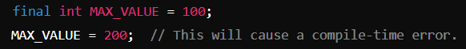

- const: The const keyword is reserved in Java but not used. Instead, Java uses the final keyword to define constants. Example: final int MAX_VALUE = 100; (not const).
- throws: The throws keyword is used in a method signature to declare that the method might throw exceptions of the specified types. It is used to propagate exceptions to the calling method.
- try: The try keyword is used to define a block of code that will be tested for exceptions during execution. It is part of exception handling and is typically followed by catch or finally blocks.
- goto: The goto keyword is reserved in Java but is not implemented. Java does not support the goto statement as it can lead to unstructured and difficult-to-maintain code. Example: Not used in Java.
- import: The import keyword is used to include Java classes or entire packages into your code. This allows the programmer to use the classes defined in other packages. Example: import java.util.Scanner; imports the Scanner class from the java.util package.
- package: The package keyword is used to define a package, which is a namespace for organizing classes and interfaces. It helps avoid name conflicts and manage code structure. Example: package com.mycompany.myapp; defines a package.
- catch: The catch keyword is used to define a block of code that handles an exception thrown by the try block. Each catch block handles a specific type of exception. They are put for the oops. If some upset difference.
Character | ASCII Codes
0-9 | 48-57
A-Z | 65-90
a-z | 97-122

Data Types
Data Type | Description
Primitive Data Types
byte | 8-bit signed integer
short | 16-bit signed integer
int | 32-bit signed integer
long | 64-bit signed integer
float | 32-bit floating-point number
double | 64-bit floating-point number
char | 16-bit Unicode character
boolean | Boolean value (true or false)
Non-Primitive Data Types
String | Sequence of characters
Array | Ordered collection of elements of the same type
Class | Blueprint for creating objects
Interface | Defines a contract for classes to implement
Enum | Fixed set of constants

Type Casting
- Implicit (Automatic) Type Conversion: occurs automatically when a smaller data type is converted to a larger data type without intervention of user. This is safe because there is no risk of data loss, as the larger type can accommodate all values of the smaller type.
    - Hierarchy of data types: the hierarchy shows or indicates the increasing order of data types. If two data of different types are operated, then resulting is automatically get converted to its higher data type.
byte char short
int
long
float
double

- Explicit (Manual) Type Conversion: Explicit type conversion, also known as narrowing conversion or casting, occurs when you explicitly convert a larger data type to a smaller data type. This requires a cast operator because it can lead to data loss if the larger type's value cannot be represented by the smaller type.

Access Specifier
Access specifiers in Java define the visibility and accessibility of classes, methods, and variables in different parts of the program. They control how the members (variables, methods, constructors) of a class can be accessed from other classes. There are four main access specifiers in Java:
  - public: When a member is declared as public, it can be accessed from any other class in the same package or any other package. This is the most permissive access level. Usage: Use public when you want to allow unrestricted access to a class, method, or variable from anywhere in your application. Example:
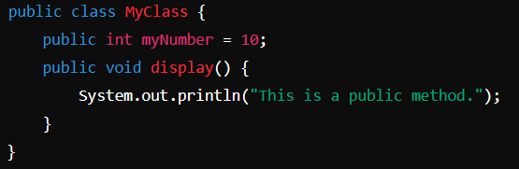
  - private: When a member is declared as private, it can only be accessed within the same class in which it is declared. It is the most restrictive access level. Usage: Use private when you want to hide the implementation details and prevent access to the members from outside the class. Typically used to enforce encapsulation. Example:
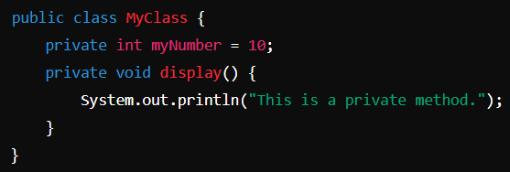
  - protected: When a member is declared as protected, it can be accessed within the same package and by subclasses in other packages. It is more restrictive than public but less restrictive than private. Usage: Use protected when you want to allow access to class members within the same package or in derived classes (subclasses) even if they are in different packages. Example:
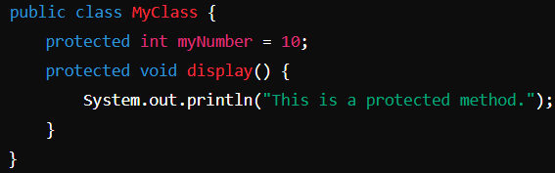
  - Default (Package-Private): When no access specifier is mentioned, the default access level is applied, which is also known as "package-private" access. Members are accessible only within the same package and not from outside the package. Usage: Use default access when you want members to be accessible only to classes within the same package. Example:
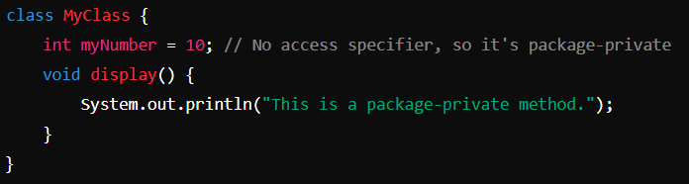
Summary of Access Levels:
Access Specifier | Same Class | Same Package | Subclass (Different Package) | Other Packages
public | Yes | Yes | Yes | Yes
private | Yes | No | No | No
protected | Yes | Yes | Yes | No
Default | Yes | Yes | No | No

Methods
In Java, methods are blocks of code that perform a specific task. They allow you to encapsulate a piece of functionality that can be reused throughout your program. Methods are a fundamental part of object-oriented programming (OOP) as they help organize and modularize code.
- Method Declaration: A method is defined with a name, return type, and a set of parameters (if any). The general syntax for declaring a method is:
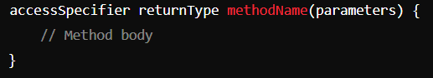
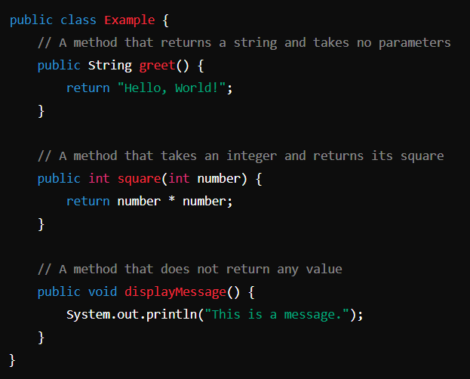
- Invoking a Method: Methods are invoked (called) using the method name followed by parentheses. If the method requires parameters, you pass them inside the parentheses.
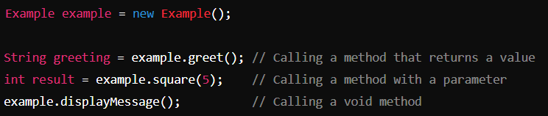
- Ways of Defining a Method
    - Parameterized returnable method: In this system of defining a method, the method header uses a list of parameters and return type.
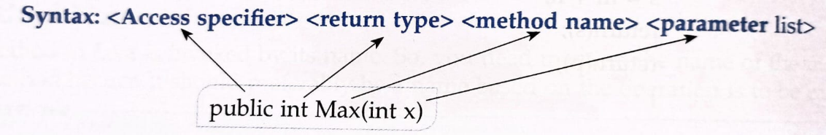
    - Parameterized non-returnable method: It may happen that the method receives a set of values but does not return the result. In this situation, the method header will use the parameters along with method name, but written type will be void.
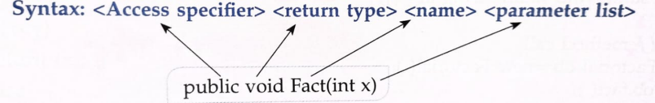
    - Nonparameterized non-returnable method: This type of method header is designed when we neither send any value to the method, nor return any value after execution. The empty braces along with the method name makes it non parameterized.
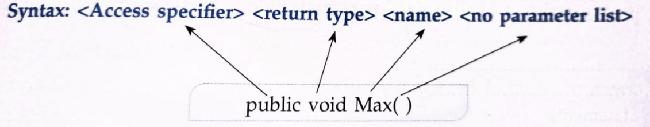

- Types of Method Modifiers
In Java, method modifiers are keywords that modify the behavior or attributes of methods. Here's a look at the different types of method modifiers, focusing on instance, static, final, and abstract methods:

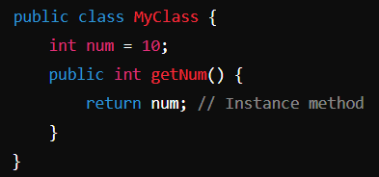
    - Instance Methods: Instance methods are non-static methods that belong to an instance of a class (an object). These methods require an object to be invoked and can access instance variables and other instance methods of the class.
- Can access both instance variables and static variables.
- Cannot be called without creating an object of the class.
- Can be overridden in a subclass.
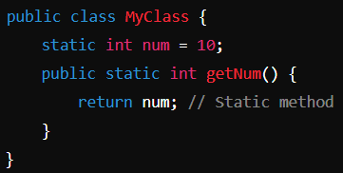
    - Static Methods: static methods belong to the class rather than any specific instance. They can be called without creating an instance of the class and can only directly access other static members (variables and methods) of the class.
- Can be called using the class name directly (e.g., ClassName.methodName()).
- Cannot access instance variables or methods directly; they can only access static variables and methods.
- Cannot be overridden but can be hidden in subclasses.

    - Abstract Methods: An abstract method is a method that is declared without an implementation. It is meant to be overridden by subclasses, which are expected to provide a concrete implementation. Abstract methods can only exist in abstract classes or interfaces.
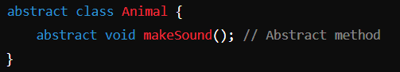
- Does not have a method body; only the method signature is provided.
- Must be implemented by any non-abstract subclass.
- Used to define a common interface for all subclasses, ensuring they implement the method.

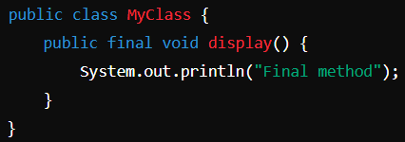
    - Final Methods: A final method is a method that cannot be overridden by subclasses. This is useful when you want to prevent subclasses from modifying the behaviour of a method.
- Ensures that the method's implementation remains unchanged in any subclass.
- Can be an instance or static method.
- Often used to enforce specific behaviour that should not be altered.
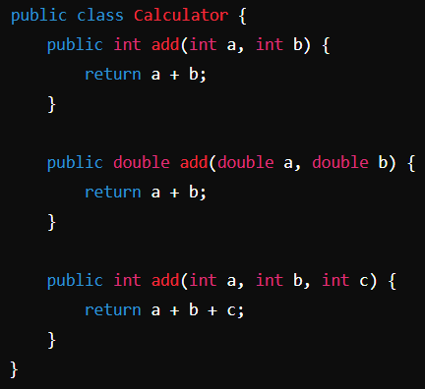
- Method Overloading: Method overloading allows a class to have multiple methods with the same name but different parameter lists (i.e., different number of parameters, types of parameters, or both). The correct method to call is determined by the method signature, which includes the method name and parameter types.
- Same Method Name: Multiple methods share the same name.
- Different Parameters: The methods must differ in the number, type, or order of parameters.
- Compile-Time Polymorphism: Method overloading is a form of compile-time polymorphism, meaning that the method to be called is determined at compile time.
- Return Type: The return type can be the same or different, but it doesn't play a role in method overloading by itself.

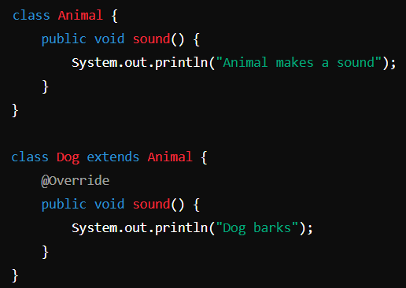
- Method Overriding: Method overriding allows a subclass to provide a specific implementation of a method that is already defined in its superclass. The method in the subclass must have the same name, return type, and parameters as the method in the superclass.
- Same Method Signature: The method in the subclass must have the same name, return type, and parameter list as in the superclass.
- Runtime Polymorphism: Method overriding is a form of runtime polymorphism, meaning that the method to be called is determined at runtime based on the object's type.
- Access Level: The access level of the overriding method cannot be more restrictive than the method it overrides.
- Annotations: The @Override annotation is often used to indicate that a method is intended to override a method in the superclass. This helps to catch errors at compile time.
- Super Keyword: The super keyword can be used within the overriding method to call the method from the superclass.

Feature | Method Overloading | Method Overriding
Definition | Multiple methods with the same name but different parameters within the same class. | Subclass provides a specific implementation of a method already defined in its superclass.
 | Must differ in number, type, or order of parameters. | Must have the same parameters as the method in the superclass.
  Parameters
 | Can have the same or different return types. | Must have the same return type (or a covariant return type).
  Return Type
Access Specifier | No restrictions based on the superclass. | Cannot reduce the visibility of the inherited method.
Polymorphism | Compile-time polymorphism (static). | Runtime polymorphism (dynamic).
Inheritance | Does not require inheritance. | Requires inheritance.

- Pass by Value and Pass by Reference
    - Pass by Value: In Java, all method arguments are passed by value. This means that when a method is called, the actual parameters are passed to the method as a copy of the original values. Changes made to the parameters inside the method do not affect the original values outside the method. Key Points:
- Primitive data types (e.g., int, char) are passed by value.
- When passing objects, the reference to the object is passed by value, meaning the reference is copied, but the object itself is not.
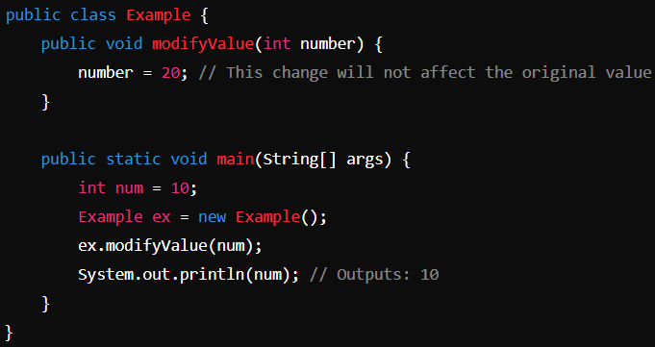
    - Pass by Reference: means passing the actual reference (memory address) of the variable to the method. Any changes made to the parameter affect the original object. Java does not support pass by reference directly, but you can achieve similar behavior by passing objects (not primitive types), as the reference to the object is passed by value. Key Points:
- Changes to the object inside the method will reflect in the original object because both the method parameter and the original reference point to the same object.
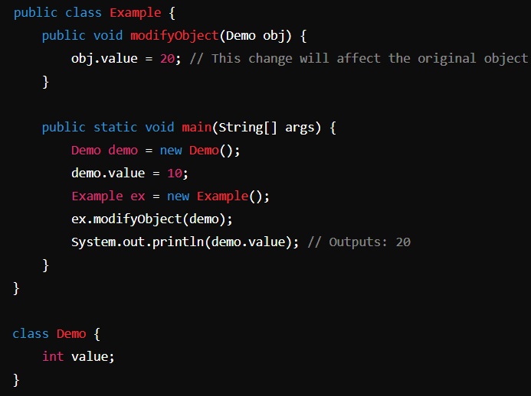
- Actual and Formal Parameter
    - Actual parameter: also known as an argument is the value or variable provided to the method when it is called.
- These are the real values that are passed to the method.
- They are used in the method call to provide inputs.
    - Formal Parameter: are the parameters defined in the method signature. They act as placeholders for the values that will be passed during the method call.
- Formal parameters are initialized with the values of actual parameters when the method is invoked.
- They are used within the method to perform operations.
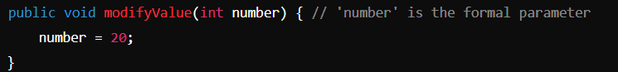

- Pure and Impure Method
    - Pure Method: is a method that, given the same input, will always return the same output and has no side effects (i.e., it does not modify any state or depend on any mutable state).
- Pure methods are deterministic and do not alter the state of the application.
- They are often used in functional programming and are easier to test and reason about.
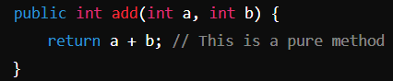
    - Impure Method: is a method that may produce different outputs for the same input or has side effects (i.e., it modifies some state or depends on a mutable state).
- Impure methods might alter the state of the application, such as modifying an object's field or writing to a file.
- They are more difficult to test and reason about because their behavior can vary.
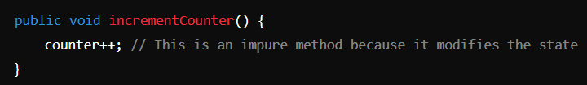
- Nested Methods: In Java, methods cannot be nested within each other (i.e., you cannot define a method inside another method directly). However, inner classes (classes defined within another class) can have methods, and they can be used in a similar way to nested methods.
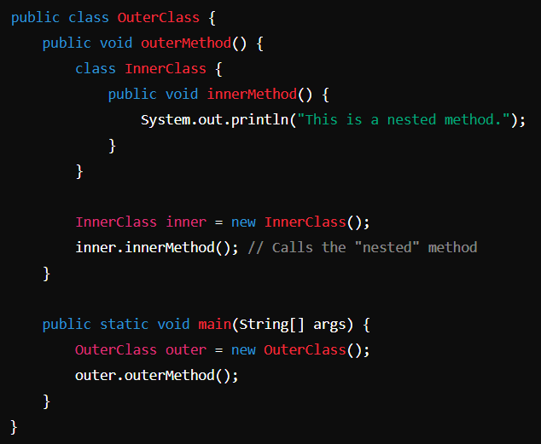
- Java does not support true nested methods, but you can create an inner class with its own methods inside an outer method.
- Some other languages do support nested methods, where a method can be defined within another method.

